**Box Model Exercise and Centering Challenge**

For this exercise you’re going to have to make a simple one-page website that demonstrates your understanding of the box model and adjustments to margins, borders and padding! Let’s get going:

Here’s how the finished page should look:

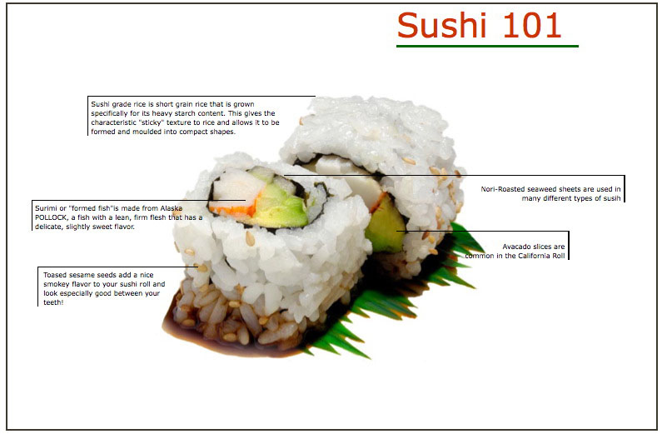

**General Directions**

1. The background image is provided. Create a html page with the sushi image as a background. Use one of our previous exercises for your basic DOCTYPE and starting structure.Then you will need to create containers for each of the definitions (see below) and place them precisely so one border line points to the item in the sushi.

**Rice**-Sushi grade rice is short-grain rice that is grown specifically for its starch content. This gives the characteristic "sticky" texture to the rice and allows it to be formed and molded into compact shapes.

**Nori**-Roasted seaweed sheets are used in many different types of sushi to wrap the contents.

**Surimi**-This formed fish paste is made from Alaska pollock, a fish with a lean, firm flesh that has a delicate, slightly sweet flavor like crab meat.

**Avacado**-Avacado slices are common in the famous California roll.

**Sesame**-Toasted sesame seeds add a nice smoky flavor to your sushi roll and look especially good between your teeth!

**Coding Hints**

Create an <article> or <figure> for each of your descriptions and give each a unique id. For example <figure id=rice> Now, to define each container,

you’ll need to use margins, padding and border rules to position containers and make the border or borders visible.

You can use negative margins (not actually needed here but you can use if necessary)

The shortcut for multiple sides of a container are:

**#rice { margin: 5px 10px 20px 5px; }**

margin-top is 5px

margin-right is 10px

margin-bottom is 20px

margn-left is 5 px

Border attributes:

border-**width thin/medium/thick or pixels**  
border-**color use any hex color**  
border-**style** solid, dashed, dotted double, groove, ridge, inset, outset

There are four parts to every border;

border-top  
border-left  
border-bottom  
border-right

Learn more about borders at:

<http://www.w3schools.com/css/css_border.asp>

**Designer Challenge**

Once you have aligned your container and the borders are pointing precisely consider this:

How would you make the page stay centered in any size browser and still keep your boxes aligned? The answer is to put the contents inside a new container just inside the body tag. This might be your <section> . You must give your container a width (same as your background image) and also give it left and right margins that are auto.

section {margin: 0 auto }